Github Tutorial

1. Go to github.com. Signup for Github
2. Click on ‘Start a new project’
3. Enter repository name and click on ‘Create Repository’

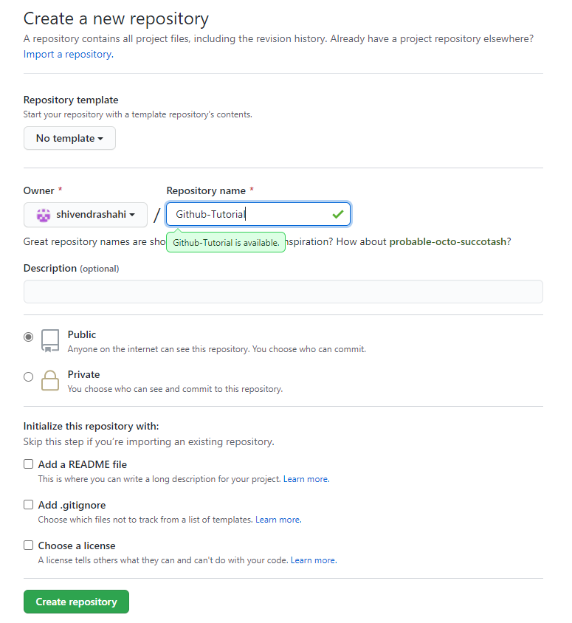

1. Initialize the repository with README file.

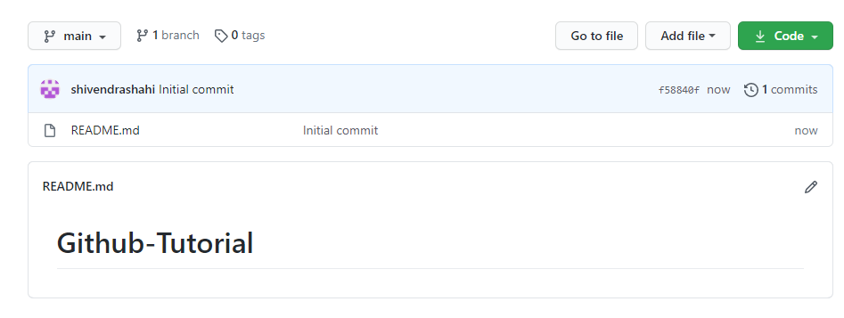

1. Create Branch in Github: Click on the dropdown ‘Branch: master’

As soon as you click on the branch, you can find an existing branch or you can create a new one

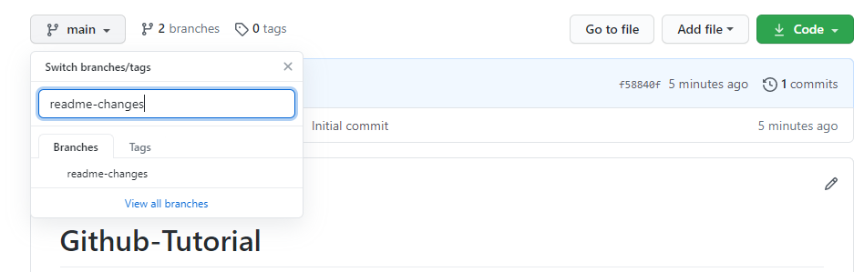

1. Edit ‘readme-changes’ file and commit changes

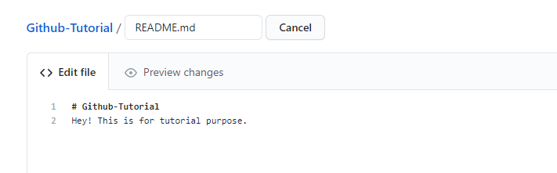

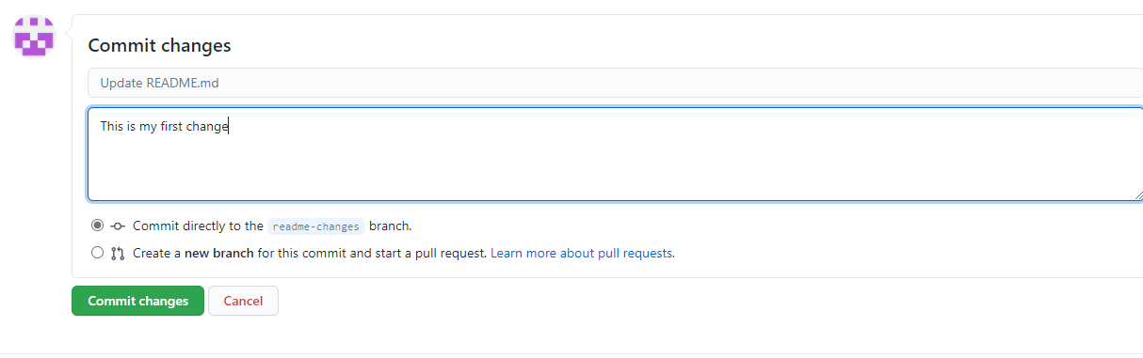

1. Pull Requests : click on new pull request

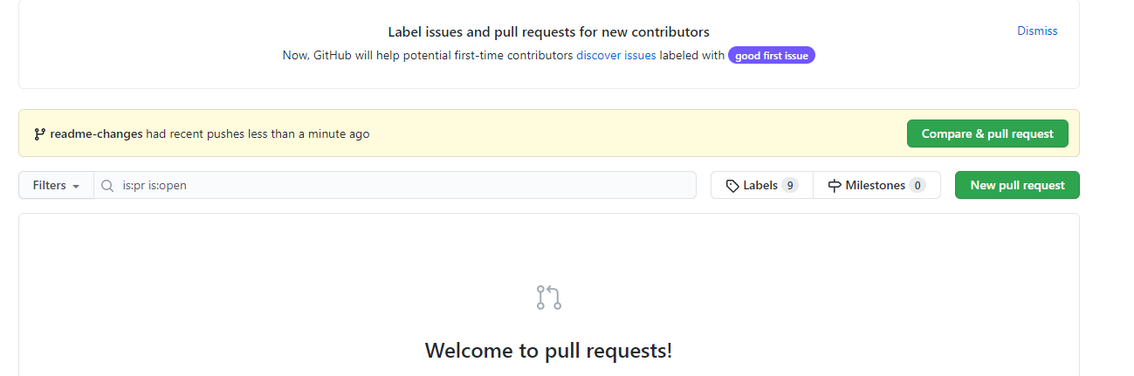

1. Create pull request

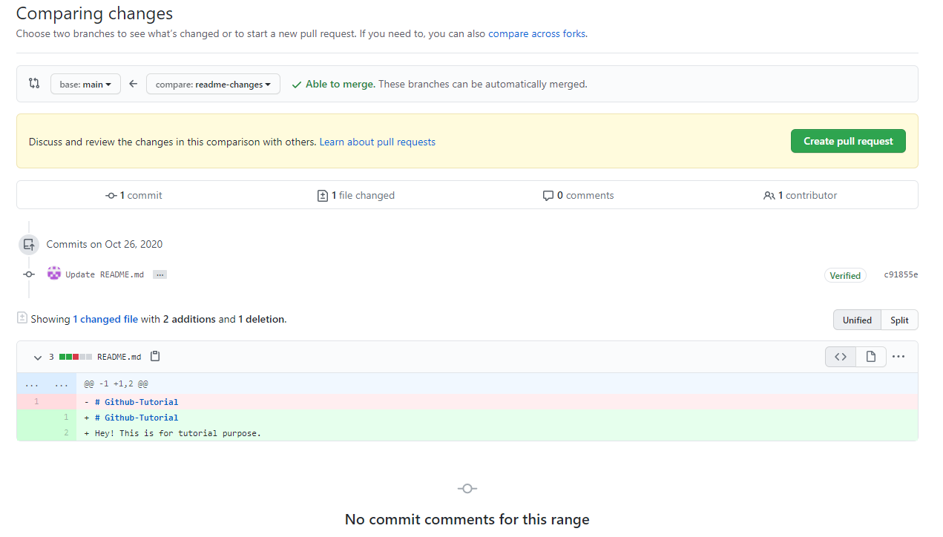

1. Merge pull request

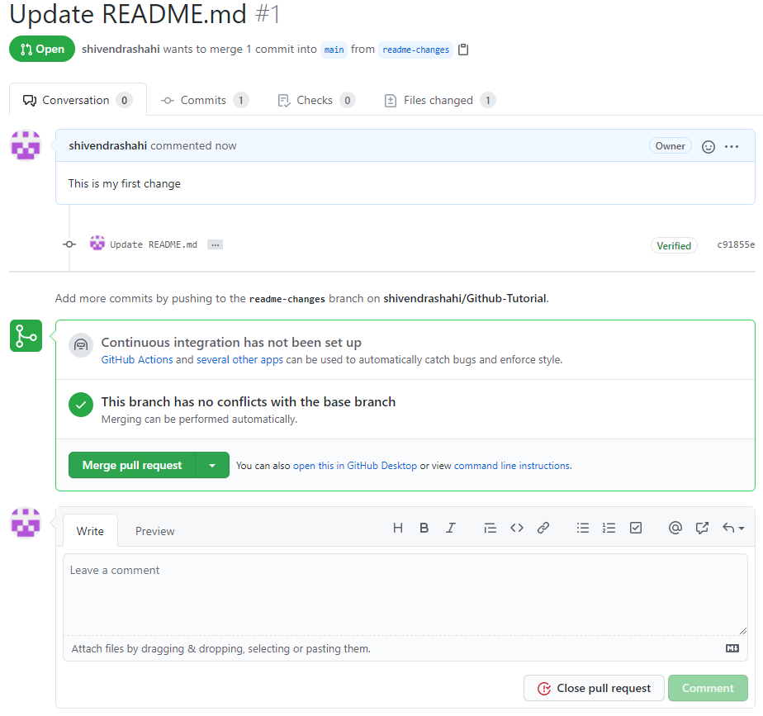

1. Click ‘confirm merge’

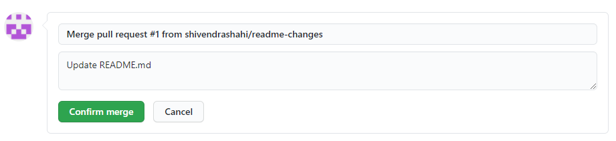

1. Cloning

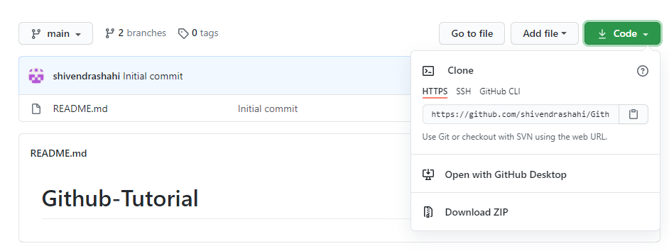

1. Import

